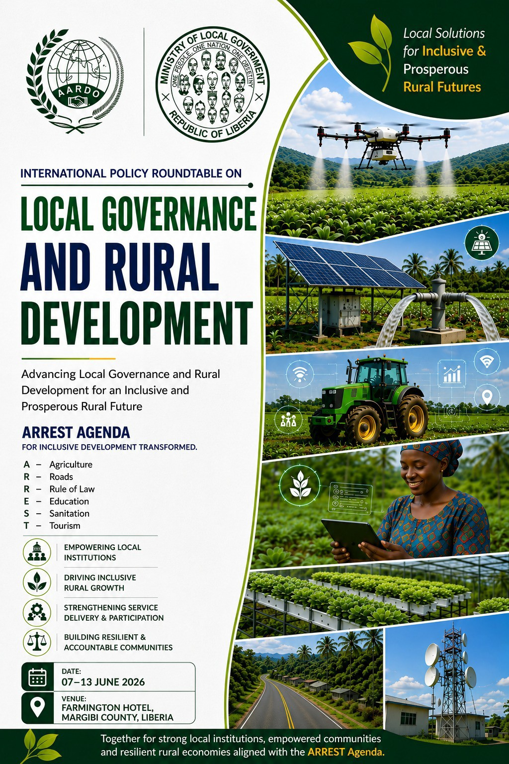
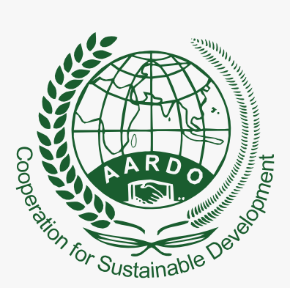




Distinguished Leadership
of
International Policy Roundtable on
Local Governance and Rural Development,
7-13 June 2026, Liberia


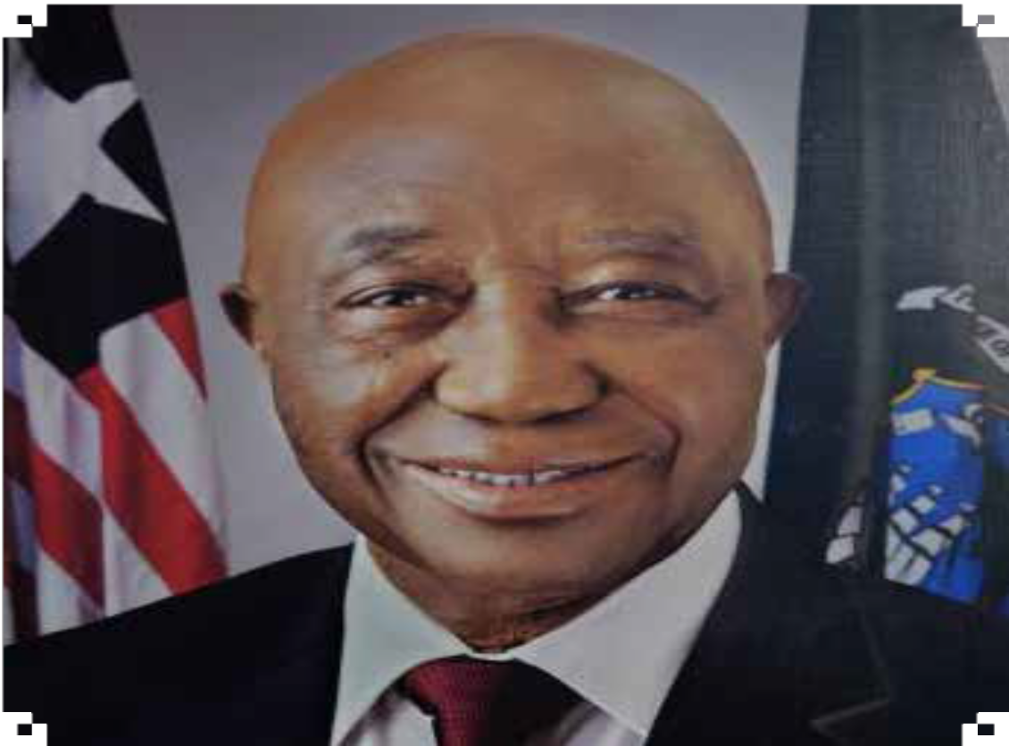
H.E. PRESIDENT OF LIBERIA
2

H.E. JOSEPH NYUMA BOAKAI, SR.

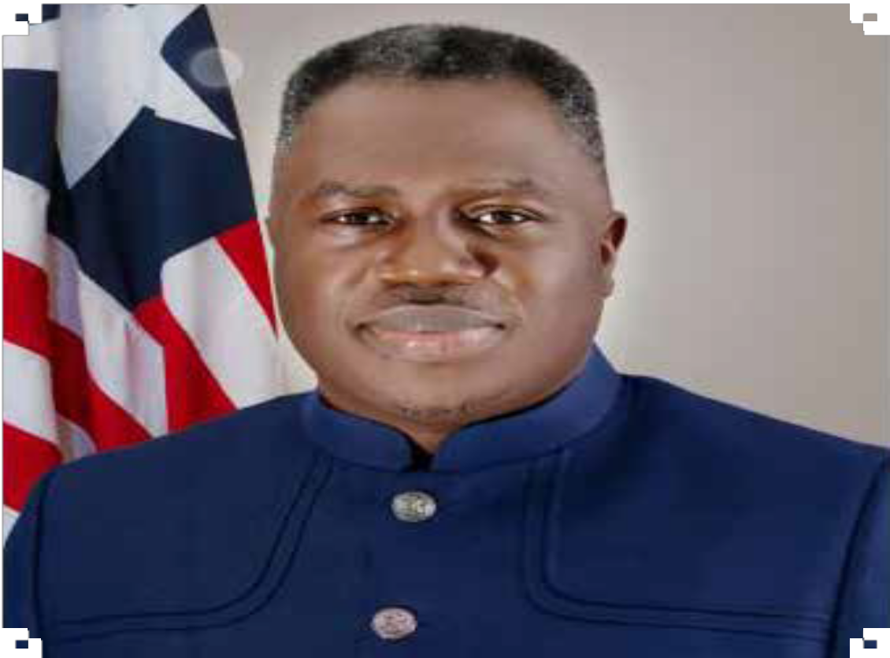
H.E. VICE-PRESIDENT OF LIBERIA

H.E. JEREMIAH KPAN KOUNG, SR.

3

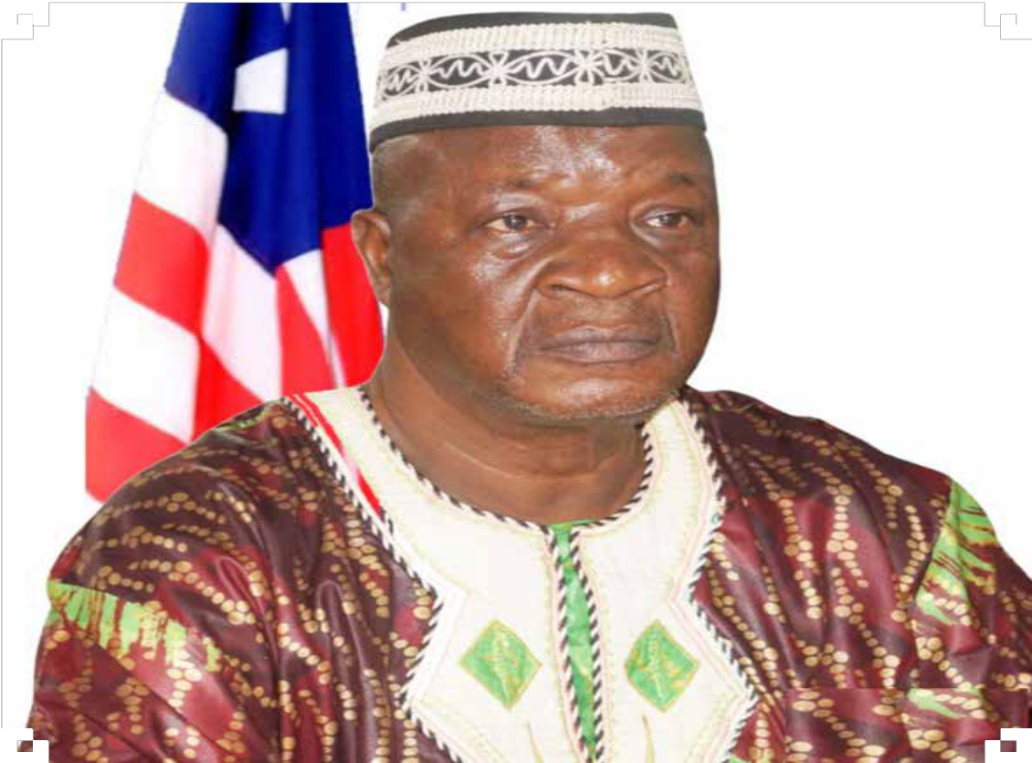
MINISTER OF LOCAL GOVERNMENT
4

HON. FRANCIS SAKILA NYUMALIN,SR.

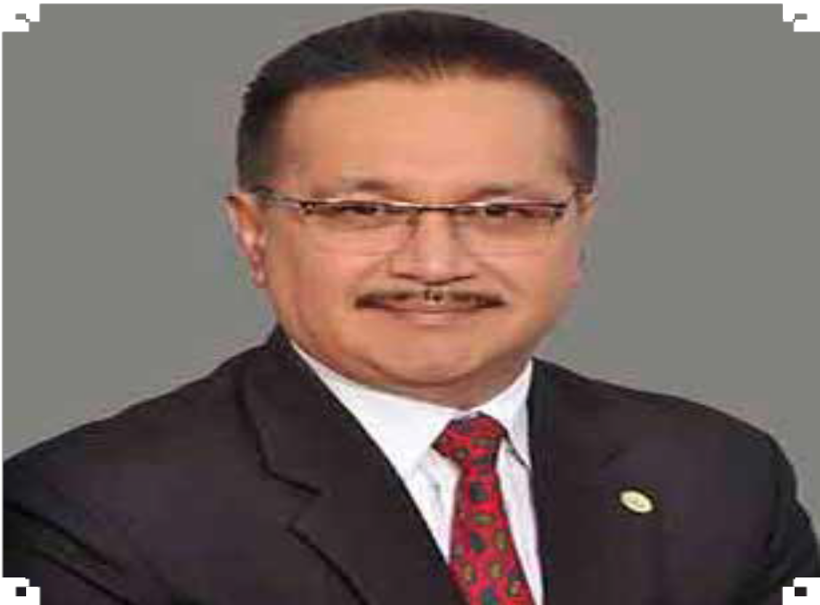
H.E. SECRETARY GENERAL AARDO

H.E. DR. MANOJ NARDEOSINGH

5

CONCEPT NOTE

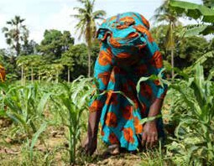
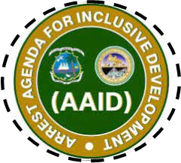
9
BACKGROUND
Effective local governance, on the one hand, bridges the gap between local/community needs and government policies and actions. On the other hand, local governance drives sustainable and localised growth in different parts of an economy, especially in rural areas.
In many countries, effective local governance is making impactful contributions towards the implementation and achievement of the Sustainable Development Goals (SDGs), as well as other regional and national development targets. Increasingly, decentralisation has emerged as a key instrument for strengthening local governance by bringing decision-making closer to citizens, improving public service delivery, enhancing accountability, and promoting greater community participation in development processes.
In Liberia, the agenda for Inclusive Development revolves around a comprehensive national framework focusing on Agriculture, Roads,
Rule of Law, Education, Sanitation, and Tourism (ARREST) as key drivers of inclusive growth and national transformation. The effective implementation of this agenda depends significantly on the strength, capacity, and resilience of local governance systems, particularly in rural areas where development challenges are most acute.
Local governments in Liberia serve as the primary interface between national policies and rural communities. They play a critical role in planning, coordinating, and delivering essential services, promoting local economic development, strengthening social cohesion, and ensuring accountability and the rule of law at the grassroots level. The Government of Liberia has undertaken important decentralisation reforms aimed at devolving administrative responsibilities and strengthening local institutions to enhance citizen participation and improve governance outcomes. These reforms present a significant opportunity to empower local authorities, improve resource allocation, strengthen institutional capacities, and ensure that development interventions are responsive to local priorities and needs.
However, despite ongoing decentralisation efforts, local governance institutions continue to face challenges related to institutional capacity, fiscal constraints, coordination gaps, limited citizen participation, inadequate technical resources, and vulnerability to climate and socio-economic shocks. Addressing these challenges is essential to building resilient local institutions capable of delivering sustainable development outcomes and supporting inclusive growth.
Across Asia and Africa, several AARDO Member Countries have implemented innovative decentralised governance frameworks, community-driven development initiatives, and rural development models that have enhanced service delivery, strengthened citizen engagement, improved local accountability, and increased resilience to emerging challenges. Drawing critical lessons from these experiences would offer Liberia a valuable opportunity to further strengthen its local governance architecture, accelerate decentralisation efforts, and adopt adaptable rural development models aligned with its national priorities and the aspirations of the ARREST Agenda.
The proposed International Policy Roundtable on Local Governance and Rural Development is designed as a high-level policy dialogue and peer-learning platform to deliberate on innovative policies, institutional mechanisms, and best practices that can support Liberia’s ARREST Agenda. Through knowledge exchange, comparative analysis, and evidence-based policy discussions, the Roundtable will facilitate the identification of practical strategies for strengthening decentralisation, enhancing local governance effectiveness, and promoting sustainable rural transformation in Liberia.

AIM
10
The aim of the International Roundtable is to garner international and regional experiences towards Liberia’s local governance systems in support of the ARREST Agenda for Inclusive Development by drawing on international lessons to enhance inclusive, resilient, and sustainable rural development through empowered local institutions.

OBJECTIVES
The specific objectives of the Roundtable are to:
- Draw comparative lessons from AARDO Member Countries on effective local governance and rural development models;
- Examine and consolidate the role of local governance institutions in implementing the ARREST Agenda at the rural level;
- Identify best inclusive, community-driven, and agriculture-led rural development approaches and their success factors;
- Strengthen institutional and human capacities frameworks for local governments;
- Analyse fiscal decentralization to back decentralization legislation and policies; and
- Formulate actionable, ARREST-aligned policy recommendations and a roadmap for implementation.
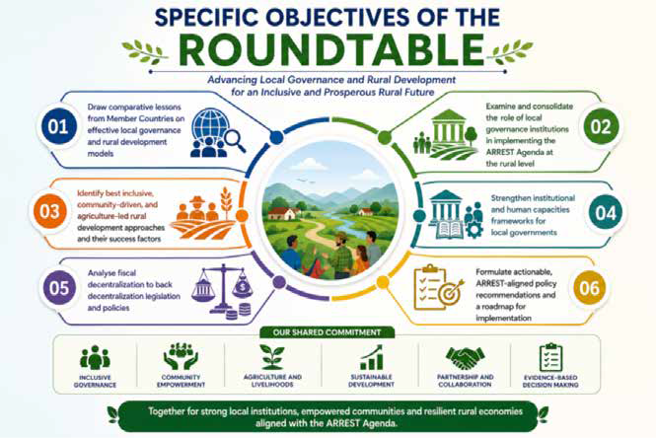

THEMATIC SESSIONS
11

PLENARY SESSION 1

Local Governance and Decentralisation Supporting SDGs, AU 2063 and the ARREST Agenda
Description : This Session will present comparative experiences from AARDO Member Countries where local governance reforms have contributed to rural transformation, service delivery, and inclusive development.

Objectives:
- Decentralization Framework and Challenges.
- Roles of County and District Administration.
- Governance Challenges.

PLENARY SESSION 2

International Experiences in Local Governance for Rural Transformation/ Country Experiences
Description: This Session will shed light on local governance related challenges and issues identified by the previous Session. It will explore ideas around access to sustainable social services and mitigation strategies to combat challenges encountered by citizens. It will also draw lessons from AARDO’s members countries.

Objectives:
- Rural Service Delivery Bottlenecks.
- Lessons from AARDO Member Countries.

PLENARY SESSION 3

Country Experiences
Description: This Session will further focus on sharing of AARDO member countries’ experiences related to local governance, service delivery and decentralization for rural transformation and accelerated rural development.

Objectives:
- Understand and appreciate experiences in AARDO member countries
- Document successful structures for local governance

PLENARY SESSION 4

Agriculture-Led and Community-Driven Rural Development Models
Description: This Session will explore alignment with the Agricultural Pillar of the ARREST Agenda, and will further explore agriculture-led growth, value chains, cooperatives, and community-driven development models that enhance rural livelihoods and food security.

Objectives:
- Examine agriculture-led rural development approaches.
- Assess local government support to farmer institutions.

PLENARY SESSION 5

Peer Learning Presentations & Moderated Discussion
This Session will draw on noble experience sharing on best practices and lessons from other AARDO member countries.

Objectives:
- Note suggestions for analysis in group discussions.
- Critically analyse successful factors and pitfalls to be avoided.

Objectives:

PLENARY SESSION 6

Agriculture-Led and Community-Driven Rural Development Models

Promote inclusion of women and youth in rural economies. Explore cooperative and value-chain-based models.
12

PLENARY SESSION 7

Institutional Capacity and Human Resource Development at the Local Level
Description: This session will address institutional and human capacity gaps within county and district administrations, focusing on leadership, planning, and performance-based governance.

Objectives:
- Assess capacity gaps in local government institutions.
- Identify priority training and skill needs.
IIII. Explore partnerships with training institutions.
IV Strengthen leadership and administrative effectiveness.
VI Design capacity-building frameworks aligned with Local Government reforms.

PLENARY SESSION 8

Financing Rural Development and Local Governance under ARREST Agenda
Description: This Session will examine fiscal decentralization, local revenue mobilization, and financing mechanisms to support rural infrastructure, sanitation, education, and livelihoods.

Objectives:
- Review Liberia’s fiscal decentralization framework.
- Identify financing constraints at the local level.
- Explore innovative financing and Public Private Partnership models.
- Promote transparent and accountable fund management.
- Share international financing experiences.

PLENARY SESSION 9
13

Digital Governance and Service Delivery for Rural Inclusion
Description: This Session will focus on the role of digital tools and e-governance in enhancing transparency, efficiency, and access to services in rural Liberia.

Objectives:
- Review digital governance initiatives in Liberia.
- Examine successful e-governance models from peers.
- Identify digital solutions for rural service delivery.
- Assess readiness for digital adoption.
- Recommend scalable digital interventions.

PLENARY SESSION 10

Climate Resilience, Policy Integration & Way Forward
Description: This Session aligns with sanitation and sustainability priorities of ARREST. It will address climate resilience, disaster preparedness, environmental governance, and WASH interventions at the local level.
Objectives:
- Assess climate and environmental risks in rural Liberia.
- Examine local government roles in climate adaptation.
- Integrate sanitation into rural planning.
- Review resilience-building practices from peers.
- Identify partnerships for sustainable rural governance.

PLENARY SESSION 11

Policy Integration, Rule of Law, and Way Forward under the ARREST Agenda
Description: This session will synthesize key lessons and focus on policy coherence, accountability, and rule of law to ensure effective ARREST Agenda implementation through local governance systems.

Objectives:
- Consolidate lessons from all sessions.
- Formulate ARREST-aligned policy recommendations.
- Strengthen accountability and rule of law at the local level.
- Identify priority actions and pilot initiatives.
- Develop a roadmap for follow-up and cooperation.

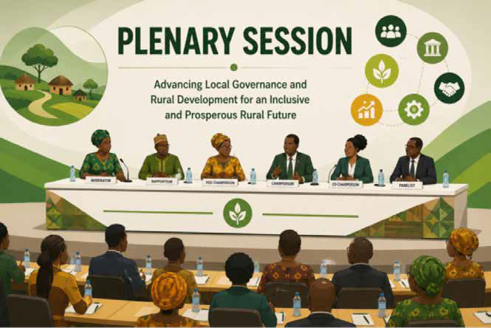
PLENARY SESSION 12
14

Adoption of Outcome Communique

Methodology

The Roundtable will adopt a participatory, evidence-based, and policy-oriented methodology, comprising:
- Preparatory Phase: Policy review, case study identification, and pre-roundtable inputs from member countries.
- Implementation Phase: Structured thematic sessions with expert inputs, country presentations, and interactive discussions.
- Synthesis Phase: Documentation of proceedings, formulation of policy recommendations, and drafting of an outcome communiqué.
- Follow-up Phase: Dissemination of outcomes, identification of pilot initiatives, and continued knowledge sharing.
The methodology will be guided by principles of country ownership, inclusiveness, scalability, and alignment with the ARREST Agenda.

Expected Outcomes
15

ARREST-Aligned Policy Recommendations
A comprehensive set of actionable policy recommendations to strengthen local governance-led rural development in Liberia.

Adaptable Rural Development Models
Identification of agriculture-led, community-driven, and resilient rural development models for piloting and scaling.

Strengthened Local Institutional Capacity
Clear pathways for capacity building of county and district administrations.

Improved Financing and Governance Mechanisms
Practical guidance on financing rural infrastructure and services with enhanced transparency.

Enhanced Regional and International Cooperation
Strengthened collaboration between Liberia and AARDO Member Countries for technical cooperation and peer learning.

Implementation Roadmap
A time-bound roadmap linking decentralisation reforms, ARREST priorities, and local governance actions.

PROGRAMME SCHEDULE

DAY 1 Monday, 8 June 2026: Opening and Technical Sessions
Theme: Setting the Context – Local Governance, Decentralization & ARREST Agenda
Time | Event
7:30 – 9:00 | Registration & Breakfast
9:00 – 10:30 | Inaugural Session: Official Opening Ceremony  Welcome address by Host:  Hon. F. Sakila Nyumalin Sr., Minister, Ministry of Local Government, Republic of Liberia  Opening Remark:  H.E. Dr. Manoj Nardeosingh, Secretary General, African-Asian Rural Development Organization (AARDO), New Delhi, India  Statement on the ARREST Agenda:  Hon. Augustine Kpehe Ngafuan  Minister, Ministry of Finance and Development Planning, Republic of Liberia  Statements:  Madam Christine N. Umutoni  Resident Coordinator, United Nations in Liberia  His Excellency Beng’yela Augustine Gang Ambassador & Doyen of the Diplomatic Corps Embassy of the Republic of Cameroon  H.E. Sara Beysolow Nyanti  Minister, Ministry of Foreign Affairs & Dean of the Cabinet Republic of Liberia  Senator Nyonblee Karnga-Lawrence  President Pro Tempore The Liberian Senate  55th Legislature (IN SESSION)  Hon. Richard Nagbe Koon  SPEAKER  House of Representatives 55th Legislature (IN-SESSION) Capitol Building, Monrovia  Cultural Performance  National Cultural Troupe  Keynote Address  H.E. Joseph Nyuma Boakai, Sr.  President of the Republic of Liberia (GUEST OF HONOR) Group Photo ALL
19

10:30 – 10:45 | Tea Break and Networking
10:45 – 12:45 | Plenary Session 1: Local Governance and Decentralization Supporting SDGs, the African Union Agenda 2063 and ARREST Agenda.  This session will present comparative experiences from AARDO Member Countries where local governance reforms have contributed to rural transformation, service delivery, and inclusive development.The session will focus on:  - Decentralization Framework and Challenges;  - Roles of County and District Administration; and  - Governance Challenges.  Moderator: Hon. F. Sakila Nyumalin, Sr., Minister, Ministry of Local Government, Liberia  Expert Speakers:  - H.E. Mr. Abdoulie Njai, Member of Parliament, Gambia National Assembly  - Hon. Edward K. Mulbah, Deputy Minister for Local Government and Decentralization, Liberia  - Prof. Alaric K.Tokpa, Acting Chairman, Liberia’s Governance Commission
12:50-13:50 | Lunch Break & Networking
13:50-15:30 | Plenary Session 2: International Experience in Local Governance for Rural Transformation/Country Experiences  This session will shed light on local governance related challenges and issues identified by the previous Session. It explores ideas around access to sustainable social services and mitigation strategies to combat challenges encountered by citizens. It will draw lessons from AARDO’s members countries.  - Rural Service Delivery Bottlenecks; and  - Lessons from AARDO Member Countries.  Moderator: Prof.Vivek Kumar, Centre for Rural Development and Technology, Indian Institute of Technology (IIT Delhi), India  Speakers:  AARDO Member Countries: Representative of i. Ghana, ii. Malaysia, iii. Oman
15:45-16:45 | Plenary Session 3: Country Experiences  This session will further focus on sharing of AARDO member countries’ experiences related to local governance,service delivery and decentralization for rural transformation and accelerated rural development.  - To understand and appreciate experiences in AARDO member countries; and  - To document successful structures for local governance.  Moderator: H.E. Dr. John Omambia Matiang’I, Minister of Environment,Water, Energy and Natural Resources County Government, Kenya  Speakers:  AARDO Member Countries: Representative of i. Gambia ii. Mauritius iii. Morocco)
17:00-17:30 | Cultural performance  The Session will display Liberia’s rich cultural heritage and traditions through art and performance.This will be led by the National Cultural Troupe of Liberia.  Facilitator: Ambassador Kekura M. Kamara, Liberia
19:00-21:00 | Reception dinner hosted by the Minister of Local Government at the Farmington Hotel; Dress Code: African/Asian Attire
20

Day-2:Tuesday, 9 June 2026
Theme: International Best Practices & Agriculture-Led Rural Development
7:30 – 9:30 | Registration & Breakfast
9:30-11:00 | Plenary Session 4: Agriculture-Led and Community-Driven Rural Development Models  This Session will explore alignment with the Agricultural Pillar of the ARREST Agenda, and will further explore agriculture-led growth, value chains, cooperatives, and community-driven development models that enhance rural livelihoods and food security.  - Examine agriculture-led rural development approaches; and  - Assess local government support to farmer institutions.  Moderator: H.E. Mr. Abdoulie Njai, Member of Parliament, Gambia National Assembly Speakers:  - Dr. J. Alexander Nuetah, Minister, Ministry of Agriculture, Republic of Liberia  - Mr. Hirofumi Kobayashi, Executive Director, Institute for the Development of Agricultural Cooperation in Asia (IDACA),Tokyo, Japan
11-11:15 | Tea/Coffee Break & Networking
11:15 – 13:00 | Plenary Session 5: Peer Learning Presentations & Moderated Discussion  This session will equally draw on noble experience sharing on best practices and lessons from other AARDO member countries.  - To note suggestions for analysis in group discussions; and  - To critically analyse successful factors and pitfalls to be avoided. Moderator: H.E. Dr. Manoj Nardeosingh, Secretary General, AARDO Co-Moderator: Ministry of Local Government, Liberia  AARDO Member Countries: Representative of i. Bangladesh ii. Burkina Faso iii. Sri Lanka iv. Zambia
13:00 – 14:00 | Lunch Break and Networking
14:00 – 16:00 | Plenary Session 6: Agriculture-Led and Community-Driven Rural Development Models  - Promote inclusion of women and youth in rural economies; and  - Explore cooperative and value-chain-based models.  Moderator: Madam Lwopu G.Kandakai,Executive Director,Cooperative Development Agency, Liberia  Speakers:  - Hon. Gbeme Horace-Kollie, Minister, Ministry of Gender, Children and Social Protection, Republic of Liberia  - Ms. Gloria Mercy, Head of Monitoring & Evaluation, EmpBindi International, Rajasthan, India  - Mr. Kishan Singh, Head of Solar Department, EmpBindi International, Rajasthan, India
16:00 – 16:15 | Tea/Coffee Break
16:15 – 17:30 | Group Discussion
21

Day 3:Wednesday 10 June 2026
Theme: Institutional Capacity, Financing & Digital Governance
8:00 – 10:00 | Registration & Breakfast
10:00 – 12:00 | Plenary Session 7: Institutional Capacity and Human Resource Development at the Local Level  This session will address institutional and human capacity gaps within county and district administrations, focusing on leadership, planning, and performance-based governance.  - Assess capacity gaps in local government institutions;  - Identify priority training and skill needs;  - Explore partnerships with training institutions;  - Strengthen leadership and administrative effectiveness; and  - Design capacity-building frameworks aligned with Local Government reforms. Moderator: Prof.Vivek Kumar, Centre for Rural Development and Technology, Indian Institute of Technology (IIT Delhi), India  Speakers:  - Hon. Nee-Alah T.Varpilah, Executive Director, Liberia Institute of Public Administration (LIPA)  - Hon. Josiah F. Joekai, Jr. (Ph.D), Director General, Civil Service Agency (CSA), Liberia  - Dr. Romelle Horton, President, Cuttington University, Liberia
12:00 – 13:00 | Lunch Break & Networking
13:00 – 14:30 | Plenary Session 8: Financing Rural Development and Local Governance under ARREST Agenda  This session will examine fiscal decentralization, local revenue mobilization, and financing  mechanisms to support rural infrastructure, sanitation, education, and livelihoods.  - Review Liberia’s fiscal decentralization framework;  - Identify financing constraints at the local level;  - Explore innovative financing and Public Private Partnership models;  - Promote transparent and accountable fund management; and  - Share international financing experiences.  Moderator: Hon.Augustine K. Ngafuan, Minister, Ministry of Finance and Development Planning, Liberia  Speakers:  - Professor Francis Maweah, Department of Regional Science, University of Liberia (UL)  - Mr. Rees Mwasambili, Country Manager, African Development Bank Group for Liberia  - Hon. James Dorbor Jallah, Commissioner General, Liberia Revenue Authority
22

14:30 – 14:45 | Tea/Coffee Break & Networking
14:45 – 16:00 | Plenary Session 9: Digital Governance and Service Delivery for Rural Inclusion  This session will focus on the role of digital tools and e-governance in enhancing  transparency, efficiency, and access to services in rural Liberia.  - Review digital governance initiatives in Liberia;  - Examine successful e-governance models from peers;  - Identify digital solutions for rural service delivery;  - Assess readiness for digital adoption; and  - Recommend scalable digital interventions.  Moderator: Hon. Sekou Kromah, Minister & Post Master General, Ministry of Posts and Telecommunications, Liberia  Speakers:  - Madam Georgia Wallen, Countr Manager,World Bank Liberia  - Prof.Vivek Kumar, Centre for Rural Development and Technology, Indian Institute of Technology (IIT Delhi), India  - Mr. Brad Constantinescu,Technical CEO, Stone Soup Tech, United States & Romania
Day 4– Thursday, 11 June 2026
Field Visit: Local Governance & Rural Development in Practice
08:30 – 17:00 | Field Visit to Selected Counties / Rural Development Initiatives  - Interaction with local authorities  - Observation of decentralized service delivery  - Community interaction
17:00 – 17:30 | Reflection Session and Key Takeaways
DAY 5: Friday, 12 June 2026
Theme: Climate Resilience, Policy Integration & Way Forward
7:30 – 9:30 | Registration & Breakfast
9:30-11:00 | Plenary Session 10: Climate Resilience, Policy Integration & Way Forward This session aligns with sanitation and sustainability priorities of ARREST. It will address climate resilience, disaster preparedness, environmental governance, and WASH interventions at the local level.  - Assess climate and environmental risks in rural Liberia;  - Examine local government roles in climate adaptation;  - Integrate sanitation into rural planning;  - Review resilience-building practices from peers; and  - Identify partnerships for sustainable rural governance.  Moderator: Dr. Emmanuel K. Urey Yarkpawolo, Executive Director, Environmental Protection Agency, Liberia  Speakers:  - Mr. Aliou Dia, Resident Representative, UNDP Liberia  - H.E Nona Deprez, Head of Delegation, European Union (EU)-Liberia  - Mr. Valentin Karm, International Consultant of Rural Innovation, Switzerland-based B. Barefoot Association  - Mr. João Maurício Marques, Founder & CEO,Yacooba Labs, Strategic Advisor - Carbon Markets, Blockchain MRV & Digital Governance Funchal,  Madeira, Portugal
23

11:15-12:15 | Plenary Session 11: Policy Integration, Rule of Law, and Way Forward under the ARREST Agenda  This session will synthesize key lessons and focus on policy coherence, accountability, and rule of law to ensure effective ARREST Agenda implementation through local governance systems.  - Consolidate lessons from all sessions;  - Formulate ARREST-aligned policy recommendations;  - Strengthen accountability and rule of law at the local level;  - Identify priority actions and pilot initiatives; and  - Develop a roadmap for follow-up and cooperation.  Moderator: Col. Gregory O.W. Coleman, Inspector General, Liberia National Police (LNP)  Speakers:  - Hon. Cllr. N. Oswald Tweh, Minister & Attorney General, Ministry of Justice, Liberia  - H. E. Dr. Manoj Nardeosingh, Secretary General, AARDO/ Prof.Vivek Kumar, Centre for Rural Development and Technology, Indian Institute of Technology (IIT Delhi), India
12:15-13:15 | Presentation of Group Outputs & Implementation Roadmap Speakers:  Group Chairpersons/rapporteurs
13:15 – 14:15 | Lunch Break and Networking
14:15-15:30 | Drafting of Communique and Statement of Roundtable
15:30-16:00 | Plenary Session 12: Adoption of Outcome Communique  Joint Press Conference: Government of Liberia and Leadership of AARDO  Co-Chairs: Honorable F. Sakila Nyumalin, Sr., Minister, Ministry of Local Government, Liberia  : H. E. Dr. Manoj Nardeosingh, Secretary General, AARDO
16:00-16:45 | Official Closing Ceremony  Presentation of the Communique to the Government of Liberia  Chair: Honorable Jeremiah Kpan Koung, Sr.,Vice President of the Republic of Liberia
13 June 2026 | DEPARTURE OF THE DELEGATES
24

